*Cosmic Shift* Wow Night!

In the creation account, Genesis 1:14 tells us, *“Then God said, ‘Let there be lights in the firmament of the heavens to divide the day from the night; and let them be for* ***signs*** *and* ***seasons*** *and for days and years.’”*

Psalm 19:1-4 proclaims:

*1 God’s splendor is a tale that is told; his testament is written in the stars. Space itself speaks his story every day through the marvels of the heavens. His truth is on tour in the starry vault of the sky, showing his skill in creation’s craftsmanship.*

*2 Each day gushes out its message to the next, night with night whispering its knowledge to all.*

*3 Without a sound, without a word, without a voice being heard,*

*4 Yet all the world can see its story. Everywhere its gospel is clearly read so all may know.*

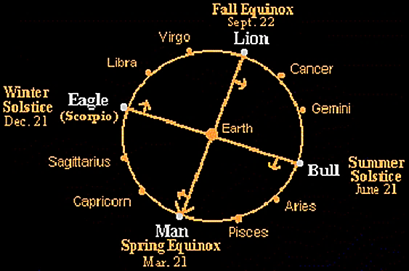

The sun, moon, and stars all give us a timeline. They display an enormous cosmic clock by which we are to tell time. We are going to take a couple of chapters out of a book entitled *Cosmic Shift* by Christopher Paul Carter. Prepare to be amazed!

[The spring equinox] is the moment of the year when the earth has an equal number of daylight and nighttime hours. The word “equinox” is a Latin word meaning “equal night.” Equinoxes…were important because it was a promise of a new season of light and longer days. The vernal (spring) equinox is a fixture in life because it marks the beginning of the year. Notice the Hebrew calendar has its first month during this time. It is a natural choice. Springtime is a season of new beginnings and new growth.

As you can imagine, early observers gave special attention to the Mazzaroth signs during these moments, and that of course meant knowing the sign in which the sun was residing. You’d expect that every year the sun would be in the same position, and in the same sign, at the spring equinox, but that is not the case. The path of the sun has a very slow progression backwards through the signs of the Mazzaroth. And when I say “slow” I mean really, really slow. The sun moves about 1 degree of a 360 degree circle every 70 years or so. That means it was just barely perceptible over the span of one human life.

To an early star watcher, this was an important shift, and it was possible to figure out how long it would take the sun to move from one sign to the next. Again, using the spring equinox as the guidepost, they knew it would take about 2,100 years for the equinox to shift one whole sign. Also, since there are 12 signs, it would take about 26,000 years for the spring equinox to move through the entire Mazzaroth!

**… “The disciples were not scholars or astronomers, yet they had in their everyday vocabulary a word for the 2,100 year progression of time. It shouldn’t be lost on us that an “age” was a well-known concept…”**

This 26,000 year cycle was a known quantity to early cultures, which makes sense when you consider that they observed and studied the firmament in ways that are lost on us today. It was easy for them to see the sun moving through the signs and the information would have been passed down the generations, from one astronomer to the next, until the pattern was understood. This pattern was the longest periodic cycle they had seen, which gave it special significance. To some early cultures, this 26,000 year motion was called the “great year.” The 2,100 year periods marked by the Spring Equinox were called “months of the great year.” They were also called “ages.” When you stop and think about it, this term is often used as a historical reference and in music. I think everyone has heard the song “Age of Aquarius” at least once. However, most of us have never realized the astronomical significance of this word, and that is particularly true when we read this word in the Bible.

Let’s take a look at a few of the times the “month of the great year” comes up. Believe it or not, this is not an exhaustive list. This term gets used quite a bit in the New Testament, mostly by Jesus, Himself:

*“For inquire, please, of the former age, and consider the things discovered by their fathers;” (Job 8:8)*

*“Therefore as the tares are gathered and burned in the fire, so it will be at the end of this age.” (Matthew 13:40)*

*“Now as He sat on the Mount of Olives, the disciples came to Him privately, saying, ‘Tell us, when will these things be? And what will be the sign of Your coming, and of the end of this age?” (Matthew 24:3)*

*“…teaching them to observe all things that I have commanded you; and lo, I am with you always, even to the end of the age.” (Matthew 28:20)*

*“…who shall not receive a hundredfold now in this time – houses and brothers and sisters and mothers and children and lands, with persecutions – and in the age to come, eternal life.” (Mark 10:30)*

*“But we speak the wisdom of God in a mystery, the hidden wisdom which God ordained before the ages for our glory.” (1 Corinthians 2:7)*

*“…which He worked in Christ when He raised Him from the dead and seated Him at His right hand in the heavenly places, far above all principality and power and might and dominion, and every name that is named, not only in this age but also in that which is to come.” (Ephesians 1:20-22)*

*“…and have tasted the good word of God and the powers of the age to come…” (Hebrews 6:5)*

The passage from Matthew, chapter 24, is a good one to look at to see just how familiar earlier scholars were with the ages. The disciples were not scholars or astronomers, yet they had in their everyday vocabulary a word for the 2,100 year progression of time. It shouldn’t be lost on us that an “age” was a well known concept to the “man on the street” (if this weren’t true, then they could have never asked this question of Jesus…you can’t ask questions using terms you don’t know). Therefore, asking Jesus about His coming and the end of the age wasn’t a vague and mysterious question as we might imagine. In fact, it was specific and direct. If we can be as familiar with these words as they were, we might start to see a whole drama unfolding in the timely shifts of the ages. We will start to see time again as it was designed.

Let’s go back, astronomically speaking, to the time of Adam and Eve. Just going on the Biblical genealogies, it would be about 6,000 years ago. Back then the Spring Equinox was in Taurus. Therefore, the sign of the age that started with the fall of man was the Bull or Ox. So when we look at the earliest cultures and their records, we find religious systems that center around the sacrifice of bulls and oxen. From ancient Greece, to Egypt, to India and beyond, spiritual life was dominated by this sign – and it stayed that way for millennia.

Then, about 2,100 years after the fall of mankind, the age begins to shift again, and Abraham comes on the scene to display the next age. Astronomically speaking, the Spring Equinox was moving into the sign of Aries, which you might recall was a lamb or ram. The first appearance of this sign occurs when Abraham is about to sacrifice his son, Isaac. As the story goes, God intervenes and provides a ram instead. Just a few short centuries after Abraham, Moses institutes an entire sacrificial system that centers on rams and lambs. The sign of Aries was demonstrated in its fullness each Passover when the Israelites sacrificed a pure, spotless lamb. Knowing the sign of the Mazzaroth, and how it changed, even brings a certain rebellion of the Israelites into focus. When Moses was on the mountain receiving the Torah, the people of Israel were worshiping a golden calf (an ox). It wasn’t just a return to pagan idolatry, it was a regression in time…a regression in the story.

Nearly 2,100 years later, the age changes again, and this time it’s Jesus who displays to the world the sign of the arriving age. For in His day the sign of the age was Pisces – the two fish being bound together and hauled out of the water. Jesus wastes no time proving to the world that He was forwarding the story of time. His first disciples were fishermen, and it doesn’t seem long before He is multiplying fish to feed a crowd, or pulling a coin out of a fish’s mouth, or meeting the disciples after He rose from the grave – while they were fishing. All of that fishy activity would seem odd for a culture that was traditionally pastoral. Even though Jesus was the “Lamb of God,” He made sure to show the world the next chapter of the cosmic story. If we needed more examples, let us look to the first symbol of Christianity – the fish. It would seem the early believers knew very well that the story of Jesus’ life, death, and resurrection were the opening acts of their new age. I like to think of them, and the patriarchs like Abraham, as the original (and more accurate) “new agers.”

Now, if you’re doing the math, you already know that we are nearing the end of this present age. The transition that Jesus marked for us so well was around 2,000 years ago. That means we stand on the verge of moving from the age of Pisces to the age of Aquarius. Turns out, that song from the 70’s wasn’t wrong...

Allow me to make just a few more points:

* First, the months of the great year really do act like chapter in a big story. When the cosmic page is turned, it affects the whole earth for the subsequent millennia. So it’s not just the stars that are shifting – we are shifting too. Think of the massive changes felt in the nation of Israel during the last shift. A sect of Judaism, now known as Christianity, was born in the blink of an eye, and then went on to change life on a global scale. On a more somber note, roughly 40 years after the shift, the nation of Israel was besieged by the Romans and the temple, along with its sacrifices, was destroyed. That temple was a prominent feature of the age of Aries, so its destruction says as much about the shift in time as anything.

Also, it’s always a person (or persons) who is turning the page into the next chapter of the story. It takes an Adam, an Abraham, or a Jesus to close the door on the past and open it to the future. Simply put, it is a human responsibility to tell the time. That makes sense, because the story we are reading is the relational story of God and us. So it is totally appropriate that the celestial drama is reflected in our earthly lives.

* Second, the cosmic clock does more than just mark the transitions and provide a symbol for religious functions; it also explains the *theme* of the age. I think we could make a case that when Abraham started the age of Aries, the story began to focus on the kind of sacrifice that would save us from destruction. The theme of that time was all about a pure offering, culminating in the crucifixion. When Jesus begins to show the signs of the next age, it’s all about “catching” people, as you would catch fish. Certainly the last 2,000 years of Christianity have focused on getting people out of the world system and into the boat with God.
* Third, the cosmic clock also shows us a central revelation for every age, and this is found by looking at the sign directly *opposite* the sun. As you know by now, the sign of the age is determined by the position of the sun at the spring equinox. Well, if you can imagine standing on the sun and looking at the sign the *earth* appeared to be in, you would see the revelatory sign of that age. Later on I’ll tell you the origin of these revelatory signs, because that story does a good job of telling us what this fast-approaching next age is all about. For now, take a look at the diagrams to see a thorough view of how the heavenly clock tells the time. Instead of starting with Adam and Eve leaving the garden, let’s go back to the age before they fell, when the creation was still perfect.

***Figure 4***

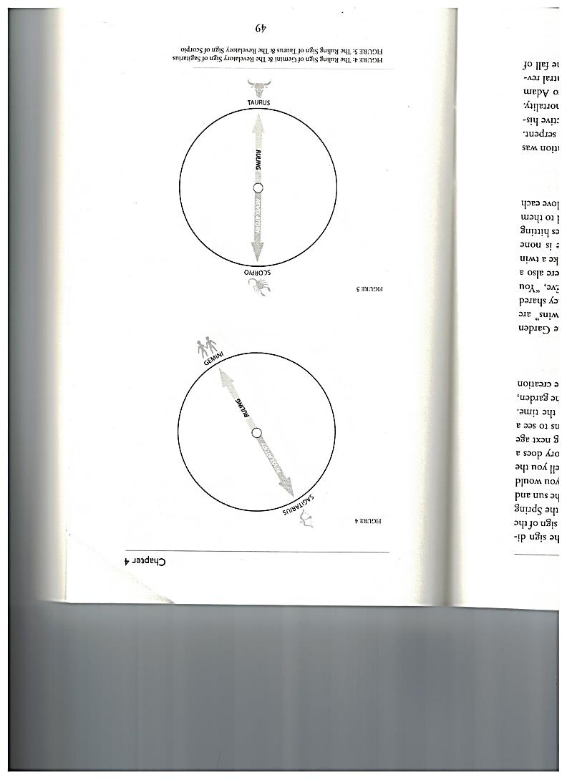

Prior to the fall, Adam and Eve were in Paradise, the Garden of Eden. The sign for that age was Gemini. The “twins” are Adam and Eve, the first two people in the garden. They shared a perfectly symmetrical relationship. Adam said of Eve, “You are bone of my bone and flesh of my flesh.” They were also a perfect reflection (or image) of God, so they looked like a twin in that respect, too. The revelatory sign for this age is none other than Sagittarius. Recall that the archer symbolizes hitting the mark and romantic love. That is what was revealed to them in that age. They were perfect, and they were made to love each other.

***Figure 5***

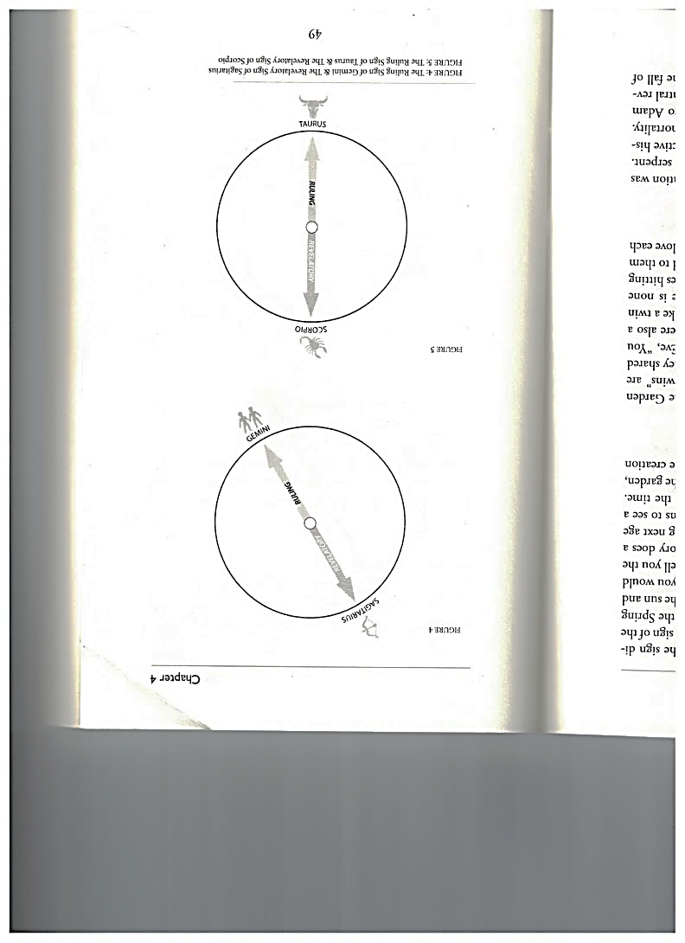

When man entered the age of Taurus, the major revelation was death and mortality, represented in the scorpion and serpent. This is, without a doubt, the biggest shift in our collective history. The fall of man was a fall from immortality to mortality. From eternal life to death. It’s hard to believe, but to Adam and Eve the reality (or possibility) of death was the central revelation of the age. The age of Taurus was the age of the fall of mankind.

***Figure 6***

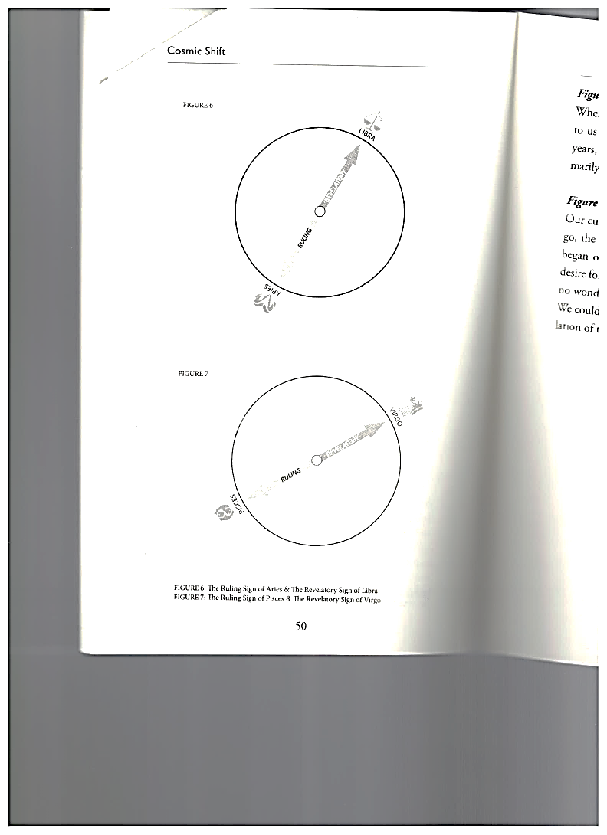

When Abraham transitioned the world into Aries, God revealed to us the Law, shown in the scales of Libra. For about 2,000 years, humanity discovered God’s judgments and statutes, primarily through Moses.

***Figure 7***

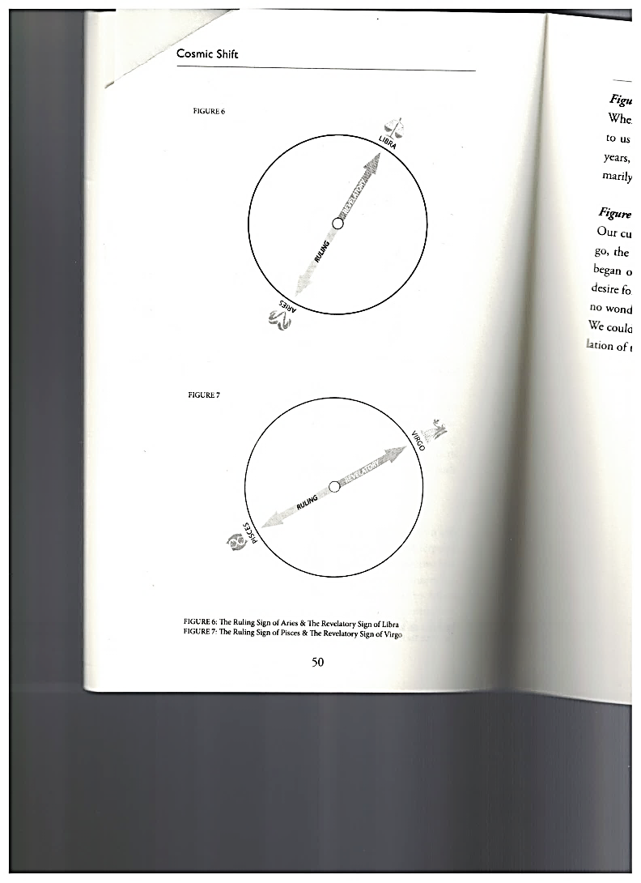

Our current age of Pisces is complemented by the sign of Virgo, the virgin woman holding a sheave of wheat. When Jesus began ordaining “fishers of men,” the story shifted to God’s desire for a harvest of souls and for the pure, spotless bride. It is no wonder that the church was called the “wife of the Lamb.” We could easily say that the Bride of Christ was a central revelation of the last two millennia.

***Figure 8***

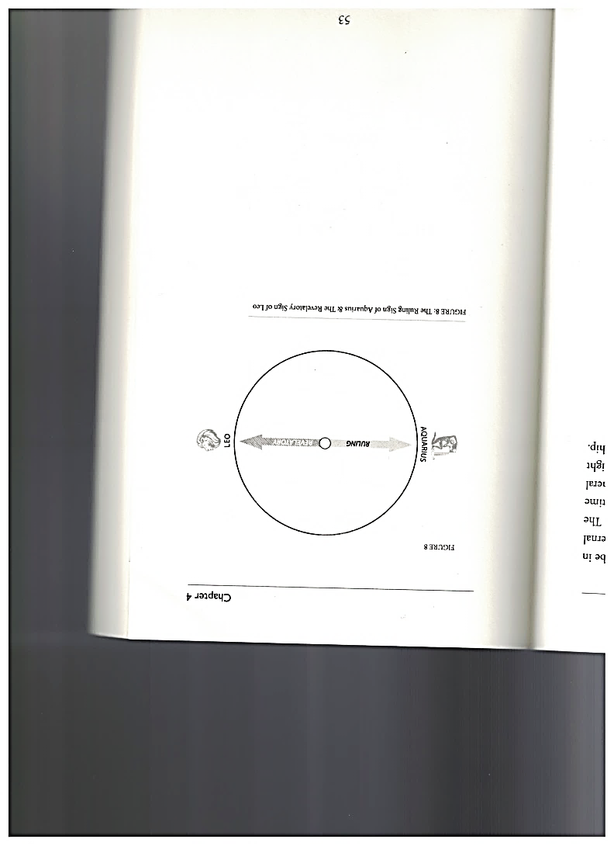

In a historically small number of years, we will officially be in the age of Aquarius. The sign of this age is the heavenly, eternal person, pouring out of their vessel rivers of living water. The major revelation of this age will be return of Jesus, this time as the King – the Lion of the tribe of Judah. In a more general sense, I believe this revelatory sign is for all of us. So we might say the revelation of this next age will be true human kingship.

**Spiritual Revisions**

It’s important to know that we aren’t in the next age yet – but we aren’t exactly in the age of Pisces anymore either. This is a time of transition; and just like the ages, themselves, the transitions can take some time. So it’s not like a cosmic light switch is flicked on and suddenly we are in the age of Aquarius. Instead, think of it like slowly closing one door while simultaneously opening another. As the door to the age of Pisces is closing, the door to the age of Aquarius is opening, and the time when both doors are open is the transition. This is just my opinion, but I would think a century is a good estimate of the length of a transition on this scale. As you would expect, the transitions are a weird time to be alive, because the flow of the story from both ages is converging on planet earth. Since I believe we are in that moment of flux right now, I also think we should take the time to define a transition. As you would expect after reading the previous chapters. I believe we can look at history to see the future.

Let’s start with the transition from the age of Taurus to the age of Aries. If we were to summarize spiritual life before Abraham, we would have to talk in generalities. Surely there were altars built for worship, and sacrifices have been a part of human/Divine relations since the beginning of human record. As mentioned before, the sacrifice of bulls was common in this period. We could even look to the example of the Tower of Babel, in Genesis 11, to get a sense of religious life in the Age of Taurus. Using that event, we can see that people valued the interaction with Heaven and took interest in interpreting the firmament.

Doubtless there were priests to perform religious duties, but there is a vagueness about religious life in this age when compared to what came after it. As soon as Abraham enters the story and sets apart God’s people, the entire direction of spiritual life takes a turn. For it is in this astronomical age that Moses appears and lays out an entire system for temple worship, temple designs, religious behavior, and priestly duties. There is no way to overstate detail of this system.

There are specific details of what kind of sacrifice is used for what. There are instructions of how priests are to serve, right down to the clothes they wear – and that got especially specific. The spiritual responsibilities of the people, best seen in the tithes and offerings made throughout the year, were also specified. And then we have to take into account what constituted worship around the tabernacle and temple. The altar for washing, the altar for burnt offerings, the lighting of the menorah, the care of the Ark, and the function of the feasts and sacrifices were all new things. The presence of the Ark, if nothing else, should give us a sense of how spiritual life changed from the days of Taurus. If you had asked any “Israelite on the street” during the opening centuries of the age of Aries, they would have marveled at how “worship” and “assemblies” had changed since the previous age. While the general concepts of worship and sacrifice were well known since the beginning, the way in which they were done had evolved into something totally different.

If you can imagine taking one of Adam’s sons and transporting him across time and space to the time of King Solomon, you might get the sense of what I’m talking about. When Adam’s son (let’s say Seth just for fun) looked at the temple and the constant activity of priests, not to mention the ornate and purposeful design, he would likely have been quite surprised. Whether he thought the changes were good or bad, he would have to admit that things had indeed changed. Maybe he would say something like, “In my day, we didn’t have any of these regulations for worship, and we didn’t know about all these feasts! Also, look at how all these priests do a specific job, and who knew that God’s presence could be localized in that golden box?!” I’m being a little facetious here, but you get the point – things really changed.

The transition from the age of Aries to the age of Pisces was perhaps even more drastic. Consider Jesus’ followers – all Jews – who became the initiators of the new spiritual life of Pisces. All they had known up until their discipleship was the kind of worship I just mentioned, but two things in particular changed the spiritual landscape for generations to come: The first was the advent (and impartation) of the Holy Spirit, which made the assemblies around the tabernacle and temple. The presence of the Holy Spirit in the believers made each capable of interacting with God in worship and service. It’s no small leap to call every believer a “royal priesthood” (1 Peter 2:9).

The second event was something I mentioned before, the destruction of the temple in 70 AD. To anyone who was following the story, this means that the sacrifices and priestly service, all fixtures of the previous age, were now impossible to do. To see the center of religious life crumbling to the ground was a severe sign of change. Imagine all the church buildings you are used to seeing suddenly collapse, and you start to get the idea. Spiritual life, as defined in the age of Aries, was no longer even possible in the Age of Pisces.

My favorite way to see this shift is to look at the apostle Paul’s letters to the early church. When Paul is teaching them how to conduct their meetings, there are literally no carryovers from the previous age. Sure, the early church met together and worshiped, so the basic function was the same; but how they did it was completely different. Notice that Paul can’t quote any passages from the Torah, Psalms, or prophets to tell them how to let multiple people prophesy and still keep a sense of order. The same is true for instructions on speaking in tongues. Also included are instructions for taking care of the poor and how to conduct oneself at communal meals. You can read most of this in 1 Corinthians 12 if you like.

Before we go on, believe me, I’m not saying the principles of Torah or the story it told were made obsolete. That cannot be the case not only because it’s the sacred scripture but also because that would be the same mistake of disregarding time that we mentioned earlier. What comes before always affects what comes after. It’s the practices and the expressions of the story that change so drastically, not the story itself. In other words, the story was still the same, but the characters and their behaviors were wildly different.

To really get this picture, imagine that the next time you showed up for church, the minister said some prayers and then began to sacrifice some doves. Amidst all the shocked faces, I’m sure many would bolt for the doors. But to the people who ushered in this current age of Pisces, it would not have been such a big deal (under the right circumstances, of course). So for them, a New Testament model of worship and assembling was a determined choice. And it was a big one. They made the shift to meet together and do things that were totally unprecedented in the age of Aries. It was their prerogative to practice prophecy, give encouragement, speak in tongues, sing songs, have communal meals, devote themselves to the apostles’ teaching, and so on. It was a choice to allow all believers to express the gifts they received from the Holy Spirit. There was room for all of this in a completely new system.

Let’s look at how spiritual organization changed when the age shifted. In Aries, there was a priestly caste of people who performed the duties of the tabernacle and temple. They were the Levites, and the job titles never got more diverse than priest or high priest. Yet again, when Paul is instructing the church on how to administrate in this new sect of Judaism, he doesn’t hearken back to any former job titles. Instead, he coins new terms like apostle, pastor, evangelist, prophet, and teacher. He describes the duties of elders and deacons, which were also new positions. So along with a totally different method of assembly and worship, we get a brand new system of offices and functions. Regardless of how all this has changed over the centuries of Christendom, the radical revisions at the turn of the age (and each age) shouldn’t be overlooked. If we miss this part of the story, we will not be ready when it happens again.

Sometimes I marvel at Paul’s courage. Even though he stayed connected to the Jewish synagogue and temple, he took an enormous leap when he started revealing spiritual life for the age of Pisces. It must have taken guts to depart from a system in which he was thoroughly trained (remember, at one time Paul persecuted the sect of Christianity on behalf of the Jewish leaders) and embark into totally uncharted waters. In a sense, he had to leave his former practices behind to even call himself an apostle. For, there were no apostles in the age of Aries. What would it take for someone like Paul to let go of his former traditions and formulate totally new ones? What would it take for one of us to let go of the standards we have practiced all our life and take part in a transition of the ages? I think we are about to find out.

In the coming decades, I believe there will be another revision. Spiritual life in the age of Aquarius will be as different from what is practiced today, as what we do today is different from the age before it. To put it another way, animal sacrifices and temple worship would seem totally strange and out of place to a modern churchgoer (think back to your local minister sacrificing a dove); and in the same way, modern (so called “normal”) church life will seem totally strange and inappropriate to the believer of the next age. There is no other way to put it. “Church” (in its now traditional sense) is specific to the age of Pisces. It will not survive (as-is) in the transition any more than the temple and its ordinances survived the last shift.

As an aside, if we find ourselves saying, “That can’t be! Church will never pass away! God created it and He wanted it to keep going forever! I refuse to believe that someday there won’t be church anymore!” then consider the following: To make those statements is to instantly know how a Jewish person must have felt during the last cosmic transition! Wasn’t this the same response many of them had to the suggestion that their practices were limited and needed to be revised? Wasn’t this a common response to the entire advent of Christianity? (Christopher Paul Carter. *Cosmic Shift: A New Season of Faith*. The Fig and the Vine Publishing, LLC, Mt. Pleasant, SC. Print. 41-63)